USAF FIRE EMERGENCY SERVICES PERSONAL PROTECTIVE EQUIPMENT PROGRAM
USAF Firefighter Helmets (USAF contract FA8056-17-D-0004)
- Overview
The United States Air Force (USAF) has awarded Curtis a set of contracts to acquire commercial Personal Protective Equipment (PPE) across the United States Air Force (USAF) enterprise. Active Air Force, Air Force Reserve Command, and Air National Guard located in the Contiguous United States (CONUS) and Outside the Contiguous United States (OCONUS) are authorized users of these contracts.
Curtis’ Prime Contracts with the USAF include three separate Firm Fixed Price, single-award, Indefinite Delivery/Indefinite Quantity contracts (1. Chem-Bio Boots; 2. Firefighting Hoods; and, 3. Firefighter Helmets).
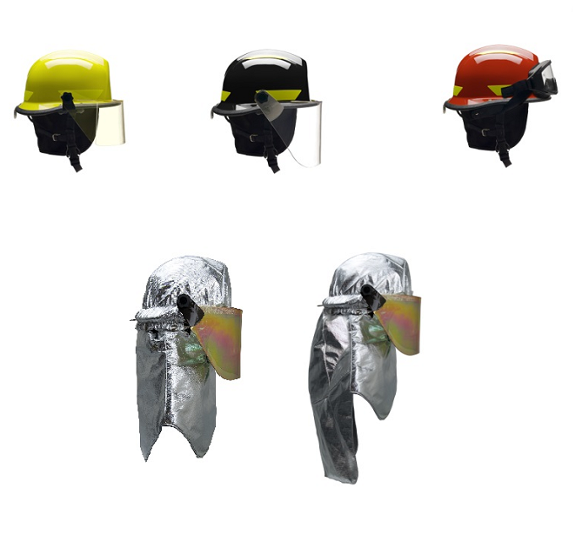
B: Structural Helmet w/ 6-inch faceshield
C: Tech-Rescue Helmet w/ goggles
A: Structural Helmet w/ 4-inch faceshield
D: Proximity Helmet with NFPA shroud (left) and extended CBRN shroud (right)

Below is a brief synopsis of this contract and how USAF agencies and affiliated personnel can purchase Structural, Proximity, and Technical Rescue Helmets and replacement helmet parts directly from Curtis.

- Product Overview
Structural Firefighting Helmet with 4-inch faceshield
Helmet for Structural Fire Fighting that meets NFPA 1971, Standard on Protective Ensembles for Structural Fire Fighting and Proximity Fire Fighting, 2013 Edition. Configured with shell, energy absorbing system, retention system, ear/neck covers, fluorescent and retroreflective trim and 4-inch faceshield. Available shell colors: white, yellow, red, black, blue, orange, and lime-yellow.
Can be configured with or without a front helmet identifier.

Structural Firefighting Helmet with 6-inch faceshield
Helmet for Structural Fire Fighting that meets NFPA 1971, Standard on Protective Ensembles for Structural Fire Fighting and Proximity Fire Fighting, 2013 Edition. Configured with shell, energy absorbing system, retention system, ear/neck covers, fluorescent and retroreflective trim and 6-inch faceshield. Available shell colors: white, yellow, red, black, blue, orange, and lime-yellow.
Can be configured with or without a front helmet identifier.
Proximity Firefighting Helmet with extended-length CBRN Shroud
Helmet for Proximity Fire Fighting that meets NFPA 1971, Standard on Protective Ensembles for Structural Fire Fighting and Proximity Fire Fighting, 2013 Edition. Configured with a compliant shell, energy absorbing system, retention system, proximity shell cover, extended CBRN length shroud, and 6-inch proximity faceshield. Available shell colors: white, yellow, red, black, blue, orange, and lime-yellow.
Proximity Firefighting Helmet with standard-length NFPA Shroud
Helmet for Proximity Fire Fighting that meets NFPA 1971, Standard on Protective Ensembles for Structural Fire Fighting and Proximity Fire Fighting, 2013 Edition. Configured with a compliant shell, energy absorbing system, retention system, proximity shell cover, NFPA length shroud, and 6-inch proximity faceshield. Available shell colors: white, yellow, red, black, blue, orange, and lime-yellow.
Technical Rescue Helmet
Helmet that meets NFPA 1951, Standard on Protective Ensembles for Technical Rescue Incidents, 2013 Edition. Available options include quick-attach goggles and four-inch faceshield. Available shell colors: white, yellow, red, black, blue, orange, and lime-yellow.
Can be configured with or without a front helmet identifier.
Helmet Replacement Parts
Available replacement parts include
- Chin Straps
- Neck/Ear Protectors
- Inner Crown System
- Helmet Front Identifier
- Proximity Cover
- 4-inch Faceshield
- 6-inch Faceshield
- 6-inch Proximity Gold Faceshield
- Goggles
- Standard-Length NFPA Shroud
- Extended-Length CBRN Shroud

- Firefighting & Technical Rescue Helmets
CLIN | Part Number  (**: shell color) | Part Name | Unit Price  (13 Sep 2019-  12 Sep 2020) | Unit of Issue | Qty Unit Pack | Days After Receipt of Order
2001AA | USRX-URM**LF | Structural Helmet  w/ 4-in faceshield and Front Helmet Identifier | $164.70 | EA | 1 | 30
2001AB | USRX/'URM** | Structural Helmet  w/ 4-in faceshield | $130.88 | EA | 1 | 30
2001AC | USRX/'URM**LFR325 | Structural Helmet  w/ 6-in faceshield and Front Helmet Identifier | $164.70 | EA | 1 | 30
2001AD | USRX/'URM**R325 | Structural Helmet  w/ 6-in faceshield | $130.88 | EA | 1 | 30
2002AA | AXUSRX/'AXM**R758 | Proximity Helmet  w/ extended CBRN-length shroud | $482.15 | EA | 1 | 30
2002AB | AXUSRX/'AXM** | Proximity Helmet  w/ standard NFPA length shroud | $409.06 | EA | 1 | 30
2003AA | USRX/'UTM**LF | Technical Rescue Helmet w/ goggles and Front Helmet Identifier | $164.70 | EA | 1 | 30
2003AB | USRX/'UTM** | Technical Rescue Helmet w/ goggles | $130.93 | EA | 1 | 30

Helmet Replacement Parts:

CLIN | Part Number | Part Name | Unit Price  (13 Sep 2019-12 Sep 2020) | Unit of Issue | Qty Unit Pack | Days After Receipt of Order
2004AA | R141 | Chin Straps | $24.18 | EA | 1 | 30
2004AB | R721 | Neck/Ear Protectors | $28.21 | EA | 1 | 30
2004AC | R929 | Inner Crown System | $92.17 | EA | 1 | 30
2004AD | R758 | Extended length CBRN Shroud | $365.30 | EA | 1 | 30
2004AE | R259 | Proximity Cover | $87.27 | EA | 1 | 30
2004AF | R330 | 4-inch face shield | $61.41 | EA | 1 | 30
2004AG | R325 | 6-inch face shield | $51.72 | EA | 1 | 30
2004AH | R340 | 6-inch Proximity Gold face shield | $124.81 | EA | 1 | 30
2004AJ | IZ4 | Goggles | $62.18 | EA | 1 | 30
2004AK | Decal Front | Front Helmet Identifier | $33.71 | EA | 1 | 30
2004AL | R756 | Standard NFPA Length Shroud | $254.72 | EA | 1 | 30
- USAF Firefighter Helmet Catalog—USAF contract FA8056-17-D-0004
Also, refer to Helmet Ordering Worksheet and Curtis’ complete USAF PPE catalog:
https://www.lncurtis.com/usg-usaf-ppe
- Contract & Ordering Information
USAF Acquisition Team:
FES PPE Acquisition Team–AFICA.PPE@us.af.mil
Procuring Contracting Officer–Robyn Boyd, Robin.Boyd@us.af.mil; 937-257-4964
Contract Specialists–Aubrey Frost, Aubrey.Frost.1@us.af.mil, 937-257-4259
Acquisition Program Manager—Todd Heinle; Todd.Heinle.2@us.af.mil; 210-395-8891
Contractor:
Contract Number: FA8056-16-D-0003
Contractor: L.N. Curtis & sons, Inc. (Curtis)
To order or for inquiries, contact Matt Foust; MFoust@LNCurtis.com; 510-268-3341, or
Government Sales Customer Service, 888-950-6677, GovtSales@LNCurtis.com

