***USAF FIRE EMERGENCY SERVICES PERSONAL PROTECTIVE EQUIPMENT PROGRAM***

***USAF Firefighter Hoods (USAF contract FA8056-17-D-0003)***

1. ***Overview***

The United States Air Force (USAF) has awarded Curtis a set of contracts to acquire commercial Personal Protective Equipment (PPE) across the United States Air Force (USAF) enterprise. Active Air Force, Air Force Reserve Command, and Air National Guard located in the Contiguous United States (CONUS) and Outside the Contiguous United States (OCONUS) are authorized users of these contracts.

Curtis’ Prime Contracts with the USAF include three separate Firm Fixed Price, single-award, Indefinite Delivery/Indefinite Quantity contracts (1. Chem-Bio Boots; 2. Firefighting Hoods; and, 3. Firefighter Helmets).

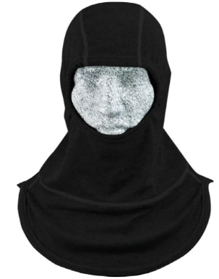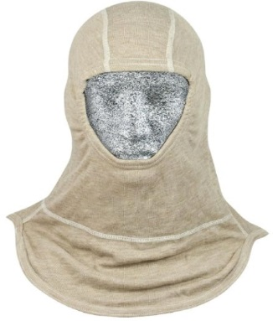

Below is a brief synopsis of this contract and how USAF agencies and affiliated personnel can purchase Structural, Proximity, and Technical Rescue Helmets and replacement helmet parts directly from Curtis.

1. ***Product Overview***

The USAF-approved firefighting hood is a lightweight, breathable hood that offers exceptional flame and heat resistance.

Properties of the USAF-approved hoods include:

* Inherently flame resistant
* Low thermal shrinkage
* Excellent TPP rating
* Superb flame resistance…lowest vertical char lengths of all hood fabrics
* Excellent Arc Flash protection (Highest arc rating of all hood fabrics)
* Compliant with NFPA 1971, Current Edition
* Excellent resistance to welding sparks and splatter…Resists pin-holing from welding sparks and splatter
* Exceptional wear life
* Comfortable…Excellent moisture absorbency–wicks moisture off skin so it can easily evaporate. Fabric also has excellent breathability

**Firefighting Hood**

Firefighting Hoods that meet NFPA 1971, Standard on Protective Ensembles for Structural and Proximity Fire Fighting, Current Edition. Double-ply hood (Para-Tek inner and outer layers) with extra-long double ply bib, tapered back and notched shoulders. Extra length covers chest, shoulders and shoulder blades. Tapered back and notched shoulder design helps bib lie flat in front and back. One size fit all. Approved for all USAF firefighters (CONUS and OCONUS delivery). Colors: black and gray

**Instructor’s Hood**

Firefighting Hoods for instructors. Hood meet NFPA 1971, Standard on Protective Ensembles for Structural and Proximity Fire Fighting, Current Edition. Three-ply hood (PBI/Lenzing FR) with double ply extra-long bib, tapered back and notched shoulders. Extra length covers chest, shoulders and shoulder blades. Tapered back and notched shoulder design helps bib lie flat in front and back. One size fit all. Approved for all USAF firefighters (CONUS and OCONUS delivery). Color: tan

1. ***USAF Firefighter Hood Catalog***—***USAF contract FA8056-17-D-0003***

***Also, refer to Curtis’ complete USAF PPE catalog:*** [***https://www.lncurtis.com/usg-usaf-ppe***](https://www.lncurtis.com/usg-usaf-ppe)

|  |  |  |  |  |  |  |
| --- | --- | --- | --- | --- | --- | --- |
| **CLIN** | **Part Number** | **Part Name** | **Unit Price**  **(13 Sep 2019-12 Sep 2020)** | **Unit of Issue** | **Qty Per Unit Pack** | **Days After Receipt of Order** |
| **2001** | 3802098-SFB | **Firefighting Hood, Black** | **$24.40** | EA | 1 | 30 |
| **2001** | 3802093-SFB | **Firefighting Hood, Heather Gray** | **$24.40** | EA | 1 | 30 |
| **2002** | 3958285-SFB | **Instructor's Hood, Tan** | **$46.41** | EA | 1 | 30 |

1. ***Contract & Ordering Information***

**USAF Acquisition Team:**

FES PPE Acquisition Team–AFICA.PPE@us.af.mil

Procuring Contracting Officer–Robyn Boyd, [Robin.Boyd@us.af.mil](mailto:Robin.Boyd@us.af.mil); 937-257-4964

Contract Specialists–Aubrey Frost, [Aubrey.Frost.1@us.af.mil](mailto:donald.loving@us.af.mil), 937-257-4259

Acquisition Program Manager—Todd Heinle; [Todd.Heinle.2@us.af.mil](mailto:Todd.Heinle.2@us.af.mil); 210-395-8891

**Contractor:**

Contract Number: FA8056-16-D-0003

Contractor: L.N. Curtis & sons, Inc. (Curtis)

To order or for inquiries, contact Matt Foust; [MFoust@LNCurtis.com](mailto:MFoust@LNCurtis.com); 510-268-3341, or

Government Sales Customer Service, 888-950-6677, [GovtSales@LNCurtis.com](mailto:GovtSales@LNCurtis.com)